Dynamic Programming Solution to Maximize the Number of Activities Selected

DYNAMIC_ACTIVITY_SELECTOR (s,f)
/* Assume that s contains start times and f contains finish times */
/* Assume that activities have been presorted by nondecreasing finish time */
/* Assume that there are n activities. */
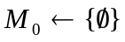
for i=1 to n
/* Build M_{i} and m_{i} */
/* M_{i} will be the list of compatibility sets for activities 1…i */
/* m_{i} will be the largest size of a compatibility set in M_{i} */
/* M_{n} and m_{n} will provide the optimal solution(s) to the overall problem*/
do 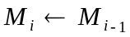
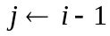
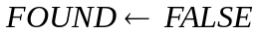
After executing this loop, j will be the largest activity number < i that is compatible with activity i.
Note that all activities < j are automatically compatible with i due to presorting by finish time.
while 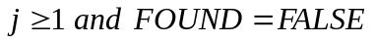
do if 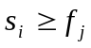
then 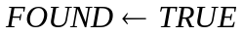
else 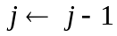
for each set 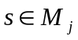
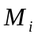starts off as 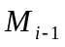.
If the ith activity can improve the solution, it does so by joining a set of activities with which it is compatible. Activities compatible with activity i are exactly those in 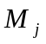. For this reason, we add i to each set in and add the result to. Note that, to avoid duplicating sets, we first remove from each set that is in .)
do 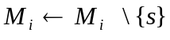 /* where \ is set difference operator */
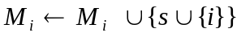
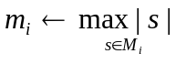
Each represents a subproblem. To solve it, we use history in two ways: we useto initialize and we use to update .

